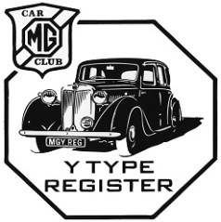26th MG Car Club Y Register Spring Weekend Saturday 4th May and Sunday 5th May 2024
The 2024 Spring Weekend will be held in Wiltshire. We will be holding the Register's AGM on Saturday at 16.30, followed by our Register dinner in the evening. The road run will take place the following day on Sunday.
Our accommodation is at Pettiffers Hotel, The Street, Crudwell, Near Malmesbury, Wilts, SN16 9EW. https://www.pettifershotel.co.uk/en/. This is a small private, Free House hotel owned and run by Frank and Lin. It is super dog friendly (on the Pets Pyjamas accommodation booking website), We will have the whole hotel for the weekend and they have offered us a very competitive B&B rates for accommodation on the Friday and Saturday, or Saturday and Sunday. (Additional days are available for those who wish to stay longer and a limited number of rooms are available for Saturday night only). Prompt booking is advisable as the hotel only has 18 rooms. Our three course dinner on the Saturday will commence at 19.00 for 19.30, with a choice of three starters, mains and pudding at only £35 per person! We will circulate the menu when it is available next year. Please note that this does not include the cost of any drinks that you may order.
Please book accommodation and pay directly with the hotel (01666 815060) quoting MG Y Register Spring Weekend (ask for Frank, Lyn or Lottie). Please book dinner via the application form and pay as outlined on that form. We will provide the menu when available next year.
Price list and accommodation options for the hotel are attached.
Pettifers Hotel Avebury Manor 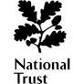
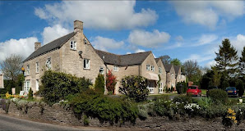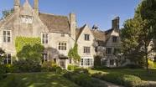
Judging for the Pride of Ownership will take place on Saturday so we can present the prizes promptly on Sunday morning at 10.00. We will be setting out for the road run from the hotel by 11.00. This will include some of Wiltshire’s famous White Horses and will end at Avebury Manor, High Street, Avebury, Near Marlborough, SN8 1RF. https://www.nationaltrust.org.uk/visit/wiltshire/avebury. Please note that individuals will be responsible for their entrance fees.
All correspondence to us (Mick & Jo) by email at rosmick@oneuk.com please. Road books and rally plaques will be available on the Sunday before the road run.

